**Raw files**

**Figure 1**

**Figure 1C western blot**

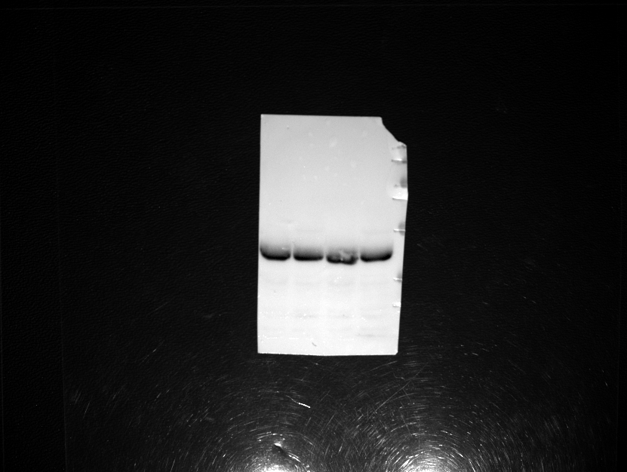

Duplicate 1

Duplicate 2

25kDa

35kDa

55kDa

70kDa

100kDa

130kDa

250kDa

Pgk1

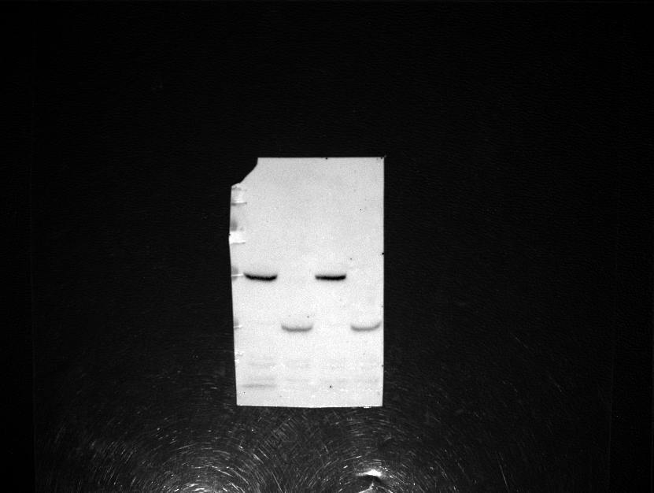

25kDa

35kDa

55kDa

70kDa

100kDa

130kDa

250kDa

Duplicate 1

Duplicate 2

Fld1-mCherry

Fld1-ΔLR-mCherry

**Figure 2**

**Figure 2G Electron microscopy raw images**

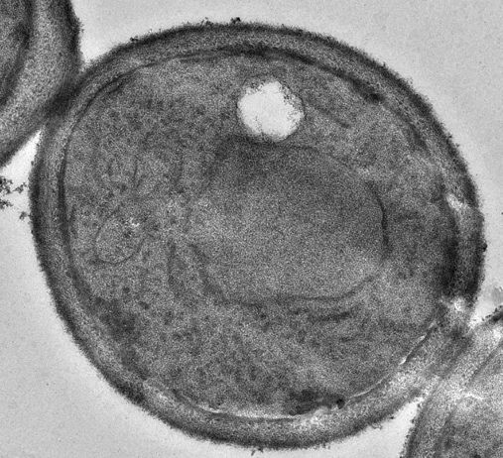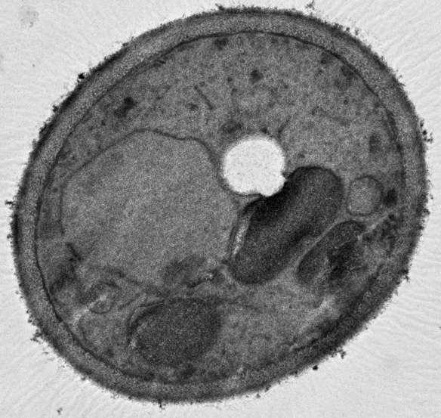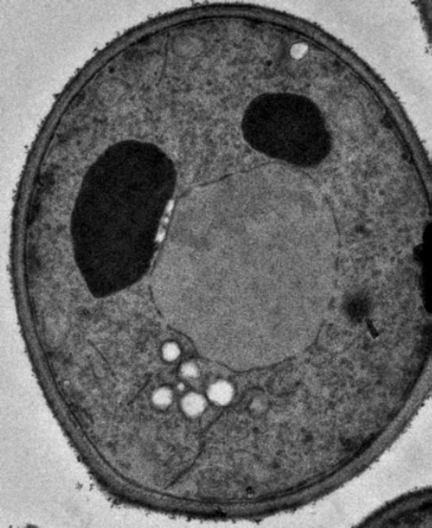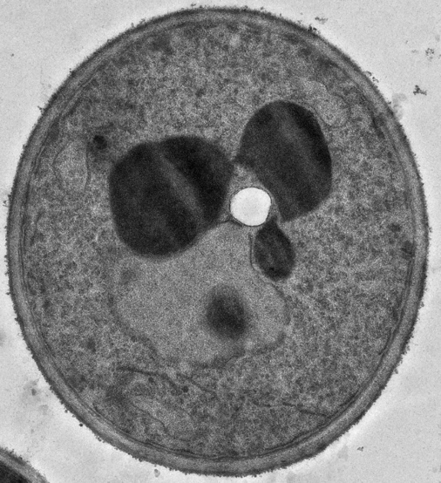

*fld1Δ +*pFld1-ΔLR

*fld1Δ* +pFld1

*fld1Δ*

WT

**Figure 5**

**Figure 5G western blot**

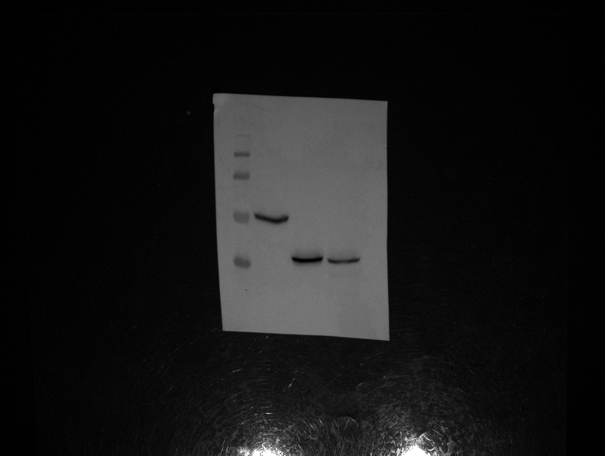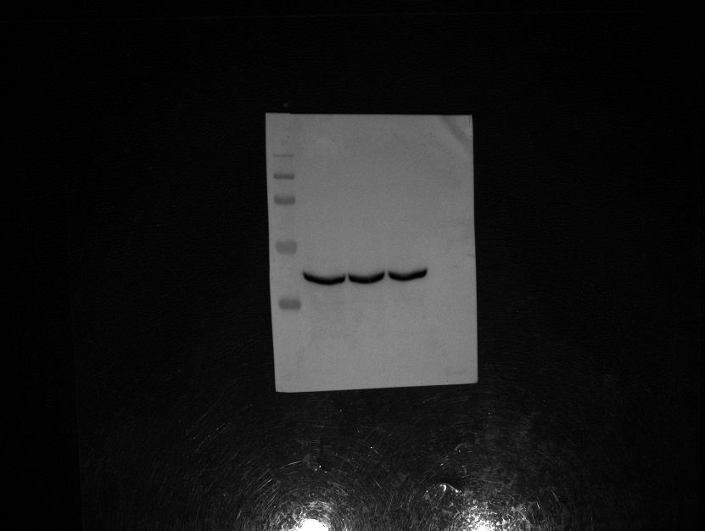

35kDa

55kDa

70kDa

100kDa

130kDa

Fld1-mCherry

Fld1-ΔLR-mCherry P31G

Pgk1

130kDa

100kDa

35kDa

55kDa

70kDa

**Figure 6**

**Figure 6C western blot**

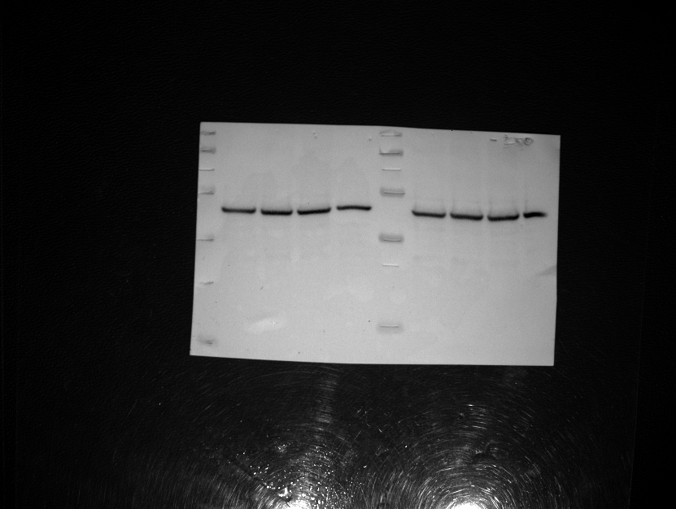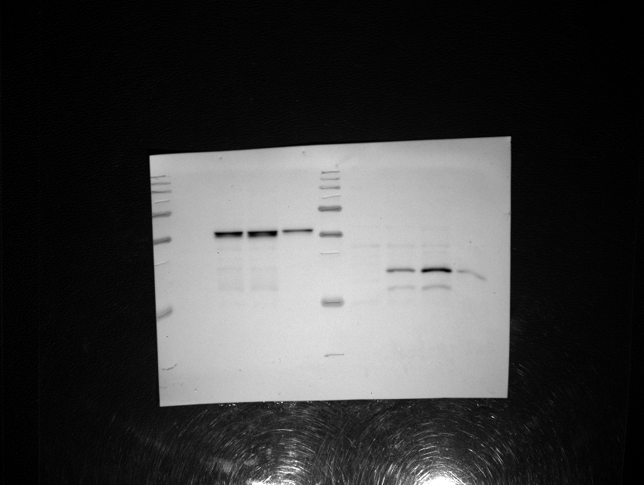

130kDa

10kDa

15kDa

25kDa

35kDa

55kDa

Fld1-ΔLR-HA

70kDa

100kDa

100kDa

70kDa

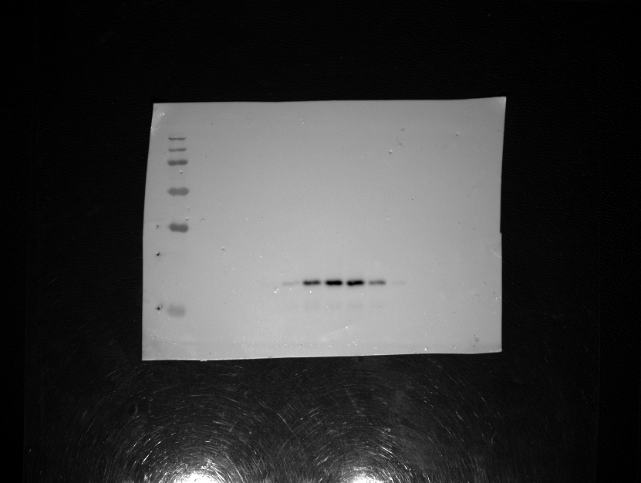

Fld1-ΔLR-HA

250kDa

130kDa

100kDa

55kDa

35kDa

25kDa

15kDa

**Figure 6D western blot**

Pgk1

55kDa

15kDa

25kDa

35kDa

Fld1-HA

**Figure 8**

**Figure 8A and 8B TLC**





**Figure 8D TLC**

*are1Δ are2Δ fld1Δ*

+ phSeipin

*are1Δ are2Δ fld1Δ*

+ phSeipin-ΔLR

STE standard

Tag standard

STE standard

Tag standard

*are1Δ are2Δ fld1Δ*

+ pFld1-ΔLR

*are1Δ are2Δ fld1Δ*

+ pFld1

*are1Δ are2Δ fld1Δ*

**Figure S3**

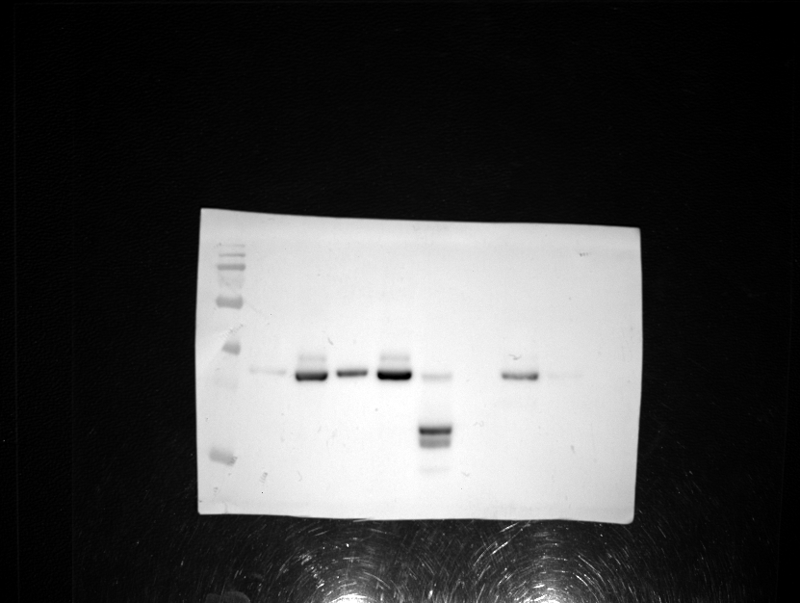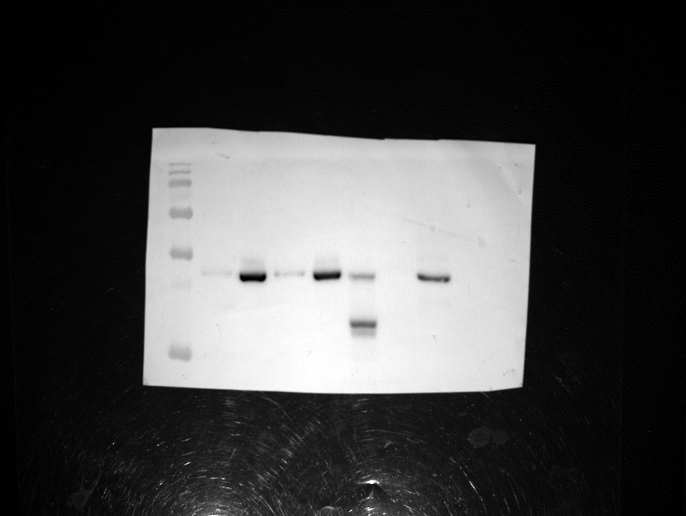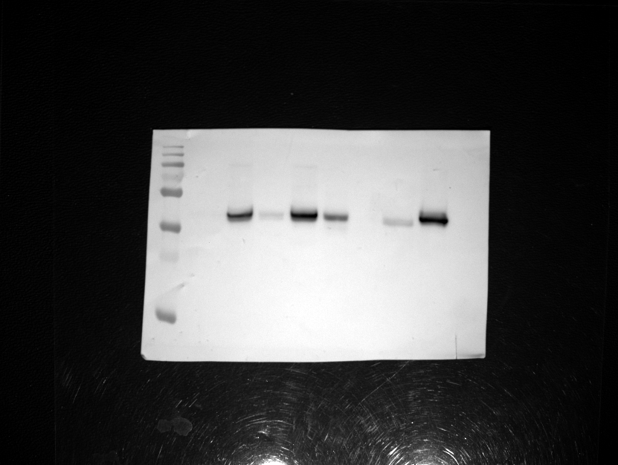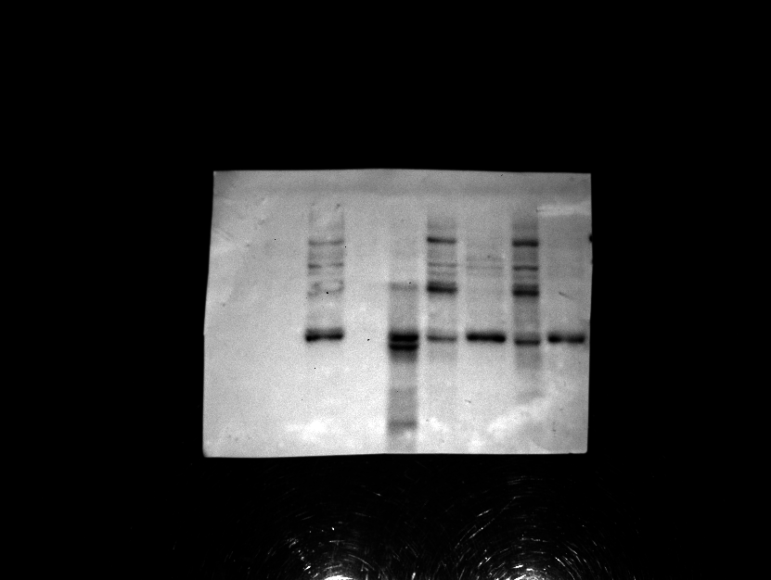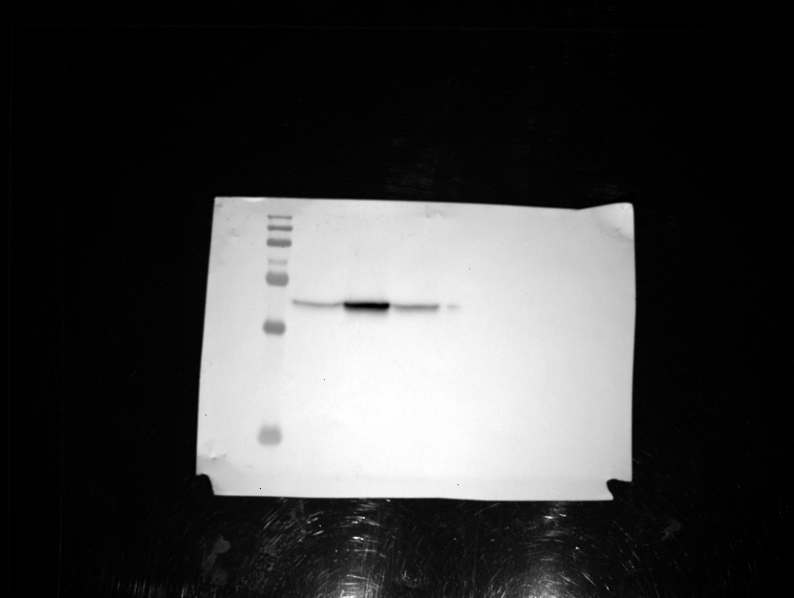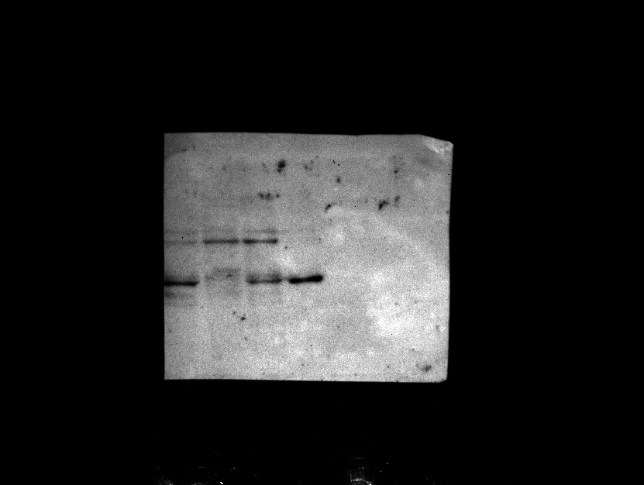**Figure S3D (homogenate)**

**Figure S3E (Salt detergent)**

DPM-1

250kDa

130kDa

100kDa

55kDa

70kDa

35kDa

25kDa

15kDa

DPM-1

250kDa

130kDa

100kDa

70kDa

55kDa

15kDa

35kDa

25kDa

Fld1-ΔLR

-mCherry

250kDa

130kDa

70kDa

55kDa

100kDa

35kDa

25kDa

15kDa

Free/Cleaved GFP

GFP-Fld1-ΔLR

25kDa

35kDa

Fld1-ΔLR

-mCherry

250kDa

130kDa

100kDa

70kDa

55kDa

35kDa

25kDa

15kDa

25kDa

35kDa

Free/Cleaved GFP

GFP-Fld1-ΔLR

**Figure S3F (Proteinase K)**

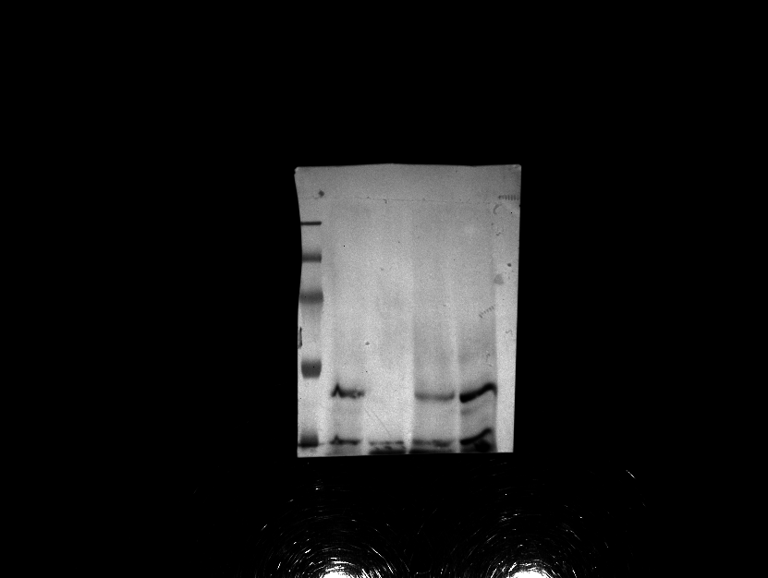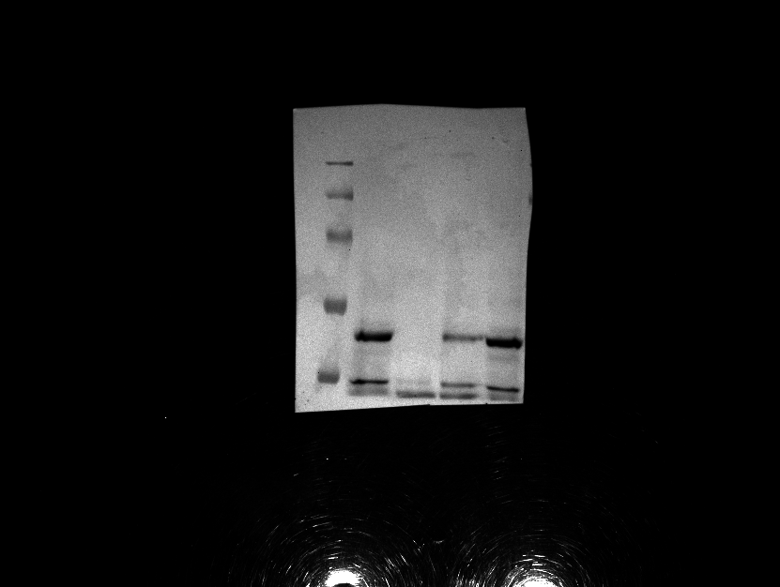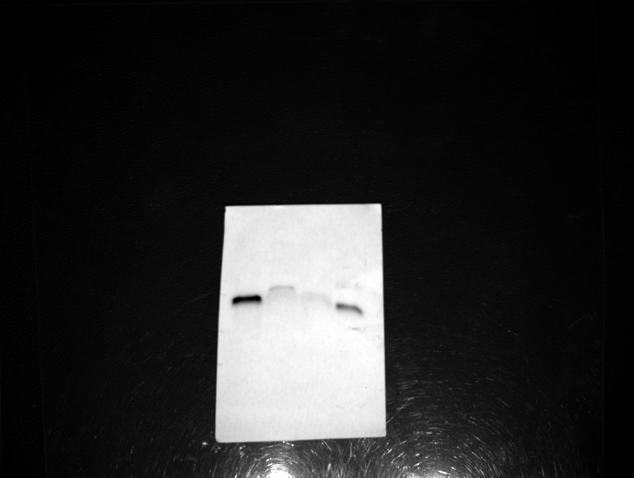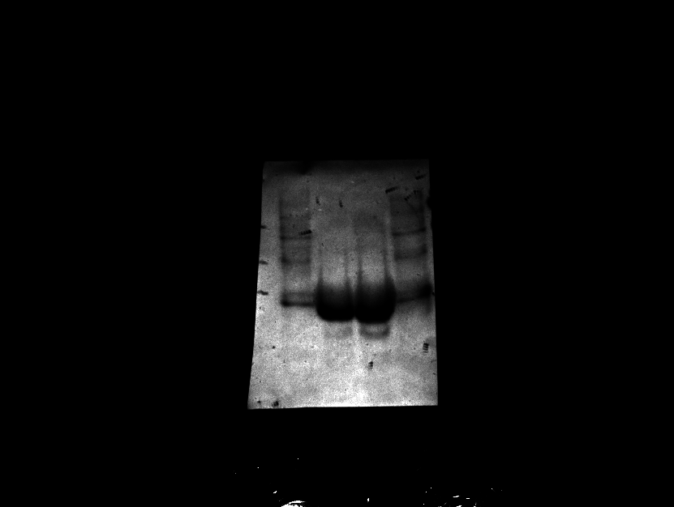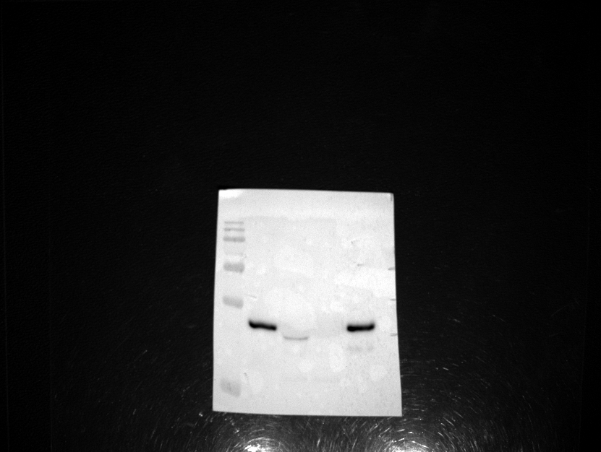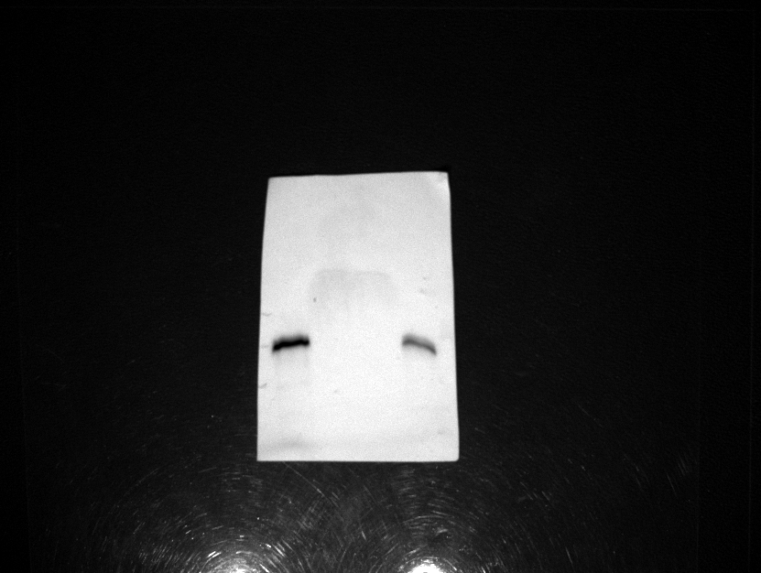

KAR2

KAR2

250kDa

130kDa

100kDa

70kDa

55kDa

55kDa

70kDa

100kDa

130kDa

250kDa

DPM-1

DPM-1

Fld1-ΔLR

-mCherry

Free/Cleaved GFP

GFP-Fld1-ΔLR

55kDa

25kDa

35kDa

250kDa

130kDa

100kDa

70kDa

55kDa

15kDa

35kDa

55kDa

35kDa

25kDa

15kDa

15kDa

55kDa

35kDa

25kDa

**Figure S5A**

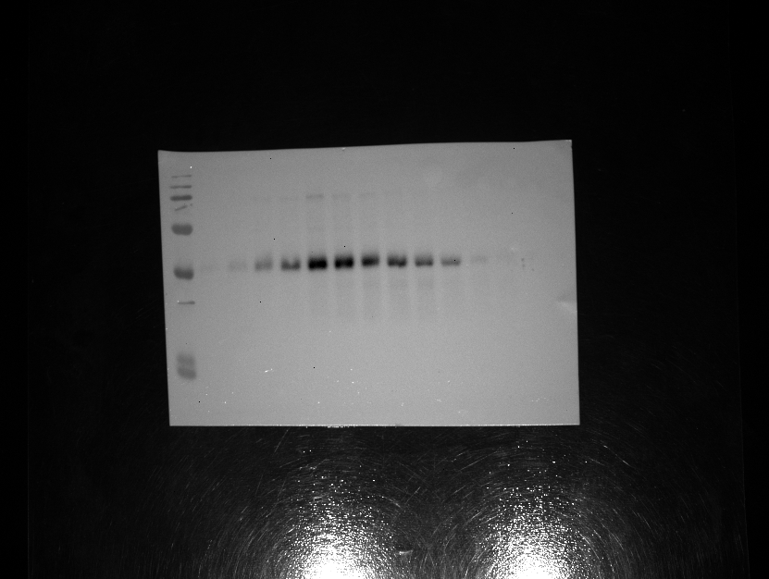

Fld1-HA

250kDa

130kDa

100kDa

70kDa

55kDa

15kDa

25kDa

35kDa

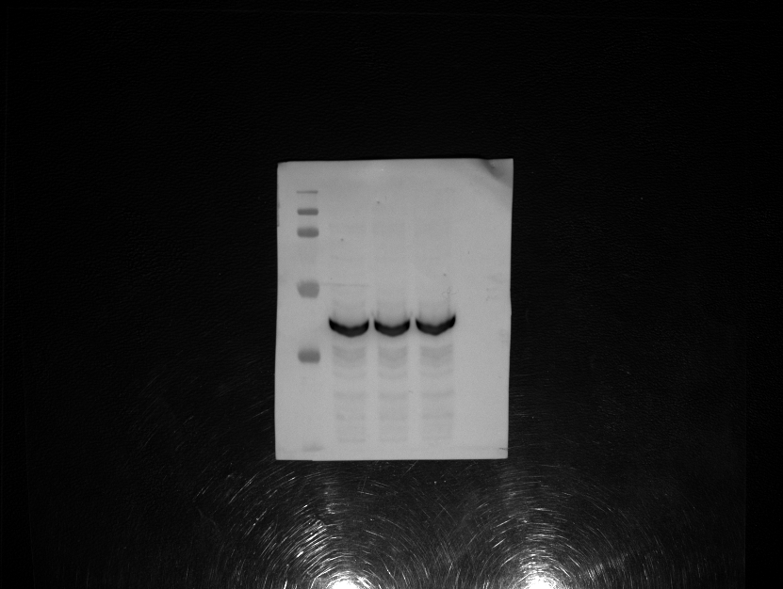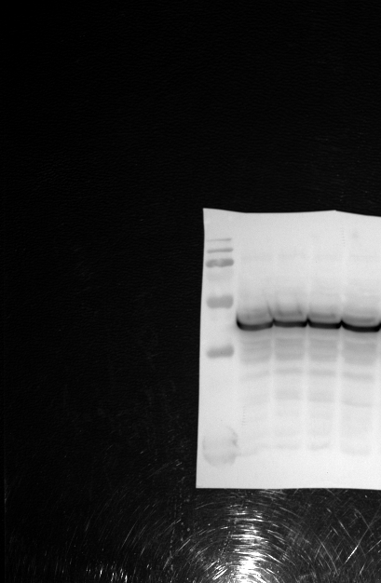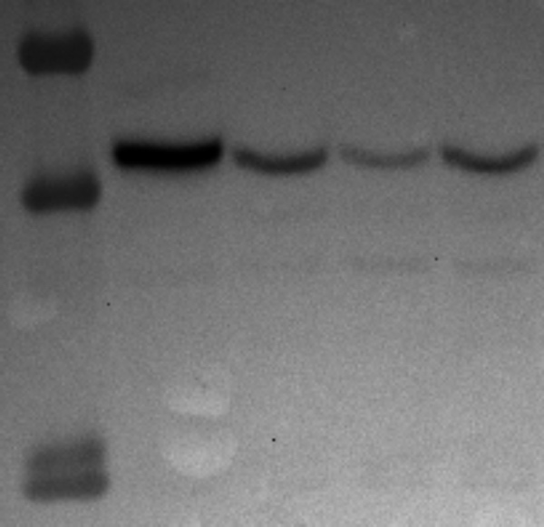

PGK1

250kDa

130kDa

100kDa

55kDa

35kDa

15kDa

Fld1-ΔLR + G235A L236A R237A Clone 2

Fld1-ΔLR + G235A L236A R237A Clone 1

Fld1-ΔLR + G235A L236A

25kDa

130kDa

100kDa

55kDa

70kDa

35kDa

15kDa

Fld1-ΔLR + single point mutants

PGK1

250kDa

130kDa

100kDa

70kDa

55kDa

15kDa

35kDa

15kDa

25kDa

55kDa

35kDa

**Figure S6D**